Table 1: Overview of Business Climate Indexes Used in this Study

Index | Comments
Fantus Company (1975)  Symbol: FT | - Commissioned by the Illinois Manufacturers’ Association.  - 15 measures that primarily related to the cost of doing business.  - Measures appeared to be equally weighted.  - To the authors’ knowledge, there are no surviving copies of the original report, only cursory discussions in secondary sources.
Grant Thornton (1979-1989)  Symbol: GT | - 1979 study commissioned by the Council of State Manufacturers’ Associations (COSMA). Thereafter, COSMA members participated, but COSMA did not financially sponsor the annual study.  - 18-22 measures primarily associated with the cost of doing business, with a few demographic and performance measures.  - Measures are weighted based on survey responses regarding measures’ importance to COSMA membership.  - Only the 48 contiguous states
Small Business Survival Index (2000-2004)  Symbol: SB | - Product of the Small Business and Entrepreneurship Council (formerly known as the Small Business Survival Council). http://www.sbsc.org/  - 15-21 measures primarily associated with the costs of doing business. Heavily weighted toward tax policy measures. Small index values indicate a “better” business climate.  - All measures equally weighted.  - The index dates back to the mid-1990s, but earlier versions were unavailable.
Metro Area and State Competitiveness Report (2001-2004)  Symbol: BH | - Product of the Beacon Hill Institute at Suffolk University. http://www.beaconhill.org/  - Approximately 40 measures categorized into 5 subindexes: Policy, Security, Infrastructure, Human Resources, Technology, and Finance.  - Each measure is equally weighted within each subindex. Each subindex is equally weighted in the aggregate index.
The State New Economy Index (1999 & 2002)  Symbol: NE | - Product of the Progressive Policy Institute. http://www.neweconomyindex.org/states/2002/  - 23 measures categorized into 5 categories: Knowledge Jobs, Globalization, Economic Dynamism, Digital Economy, and Innovation Capacity. Measures focus on technology-related areas.  - Weights applied to each measure to mitigate the influence of closely correlated measures.

Index | Comments
Economic Freedom Index 2004  Symbol: FrN (All gov’t)  Symbol: FrS (S&L gov’t) | - Product of the Fraser Institute and the National Center for Policy Analysis. http://www.fraserinstitute.ca/ http://www.ncpa.org/  - The methodology was applied to both U.S. and Canadian data at both the national and subnational levels of government. The index is reported at both levels of sggregatrion.  - 10 measures related to the size of government and the regulation of markets in three categories: Size of Government, Takings and Discriminatory Taxation, and Labor Market Freedom.  - Each measure is equally weighted within each subindex. Each subindex is equally weighted in the aggregate index.
The U.S. Economic Freedom Index (2004)  Economic Freedom in America’s 50 States (1999)  Symbol: PRI | - The 2004 index is a product of the Pacific Research Institute (in association with Forbes Magazine). The 1999 index is a product of the work of three Clemson University economics professors. http://www.pacificresearch.org/ http://freedom.clemson.edu/  - The 1999 Clemson index (used in the present analysis) is the intellectual forerunner of the 2004 PRI report.  - Dozens of metrics categorized into five categories: Fiscal Sector, Regulatory Sector, Judicial Sector, Size of Government, and Welfare Spending.  - Lower index scores means greater economic freedom.  - The 1999 Index has a two-part weighting procedure. Individual measures within each category are given decile-based scores, and the decile score of the various measures within each category are averaged to produce a category score. In 1999, the category scores were aggregated into a single index using weights from principle components analysis. In 2004, the aggregation used weights from regression coefficients relating the categories to interstate migration between 1995-2000.
Development Report Card of the States—Policy Index (1987-1992)  Symbol: CEDdp | - Product of the Corporation for Enterprise Development http://drc.cfed.org/. CFED retired the Development Report Card in 2007  - Dozens of measures separated in to eight subindexes.  - Each measure equally weighted in each subindex. Each subindex equally weighted in the aggregate Policy index.  - Measures focus on the existence of government-based economic development programs.

Index | Comments
Development Report Card of the States—Capacity Index (1987-2004)  Symbol: CEDc | - Product of the Corporation for Enterprise Development http://drc.cfed.org/. CFED retired the Development Report Card in 2007  - 26-30 measures separated into five subindexes: Human Resources, Technology, Finance, Infrastructure, and Amenities.  - Each measure equally weighted in each subindex. Each subindex equally weighted in aggregate Capacity index.
Development Report Card of the States—Fiscal Policy Index (1988-1998)  Symbol: CEDpi | - Product of the Corporation for Enterprise Development http://drc.cfed.org/. CFED retired the Development Report Card in 2007  - 16-18 measures separated into three subindexes: Fiscal Stability and Balance, Tax Fairness, and Fiscal Equalization.  - Separate reporting of this index began with the 1988 report (but was part of the 1987 Policy Index).  - Each measure equally weighted in each subindex. Each subindex equally weighted in aggregate Capacity index.
State Business Tax Climate Index (2003-2004)  Symbol: TF | - Product of the Tax Foundation http://www.taxfoundation.org/  - The 2003 index was comprised of 5 major indexes: Corporate Income Tax, Individual Income Tax, Sales and Gross Receipts Tax, Fiscal Balance, Tax Base Conformity. The major indexes contain 18 subindexes and 32 measures.  - Each major index is weighted equally to form the aggregate index. Each sub-index is weighted equally within the major indexes. In many instances, a measure equals a sub-index (e.g., tax rates)  - The 2004 index replaces adds the Conformity index variables into the other major indexes and adds an Unemployment Tax index. It also expands the number of sub-indexes and measures, and alters the weighting scheme to diminish the weights of “yes-or-no” variables.

Table 2: Intertemporal correlations for repeated business climate indexes, various years
 | GT80 | SB00 | NE99 | BH01 | PRI99 | CEDdp87 | CEDc87 | CEDpi88 | TF03
X(T+1) | 0.81 | 0.97 |  | 0.97 |  | 0.84 | 0.85 | 0.75 | 0.99
X(T+2) | 0.81 | 0.96 |  | 0.96 |  | 0.84 | 0.83 | 0.74
X(T+3) | 0.81 | 0.92 | 0.96 | 0.84 |  | 0.68 | 0.79 | 0.74
X(T+4) | 0.76 |  |  |  |  | 0.71 | 0.72 | 0.71
X(T+5) | 0.72 |  |  |  | 0.86 |  | 0.73 | 0.61
X(T+6) | 0.62 |  |  |  |  |  | 0.73 | 0.61
X(T+7) |  |  |  |  |  |  | 0.74 | 0.61
X(T+8) |  |  |  |  |  |  | 0.73 | 0.58
X(T+9) |  |  |  |  |  |  | 0.68
Correlations represent the earliest available index X at time T with values of the same index taken at time T+t, t=1, 2, 9.

Table 3: Correlations across Business Climate Indexes, Various Years
 | GT81 | FT75 | SB00 | BH01 | NE99 | FrNG04 | FrSG04 | PRI99 | CEDdp89 | CEDc92 | CEDpi92 | TF03
GT81 | 1
FT75 | 0.71 | 1
SB00 | 0.39 | 0.36 | 1
BH01 | -0.12 | -0.35 | -0.05 | 1
NE99 | -0.12 | -0.45 | -0.12 | 0.63 | 1
FrNG04 | -0.36 | -0.12 | -0.45 | -0.20 | -0.24 | 1
FrSG04 | -0.46 | -0.28 | -0.58 | -0.12 | -0.17 | 0.90 | 1
PRI99 | 0.69 | 0.71 | 0.47 | -0.05 | -0.34 | -0.35 | -0.42 | 1
CEDdp89 | -0.60 | -0.58 | -0.51 | 0.19 | 0.35 | 0.41 | 0.46 | -0.67 | 1
CEDc92 | -0.31 | -0.48 | -0.19 | 0.62 | 0.81 | -0.11 | -0.04 | -0.39 | 0.51 | 1
CEDpi92 | -0.23 | -0.27 | -0.54 | 0.07 | 0.07 | 0.34 | 0.50 | -0.21 | -0.46 | -0.12 | 1
TF03 | 0.50 | 0.35 | 0.75 | 0.10 | 0.07 | -0.52 | -0.61 | 0.44 | -0.52 | -0.04 | -0.63 | 1
GT81 | Grant Thornton
FT75 | (-1)* Fantus
SB00 | (-1)*Small Business Survival Index
BH01 | Beacon Hill
NE99 | New Economy Index
FrNG04 | Fraser Institute/NCPA Economic Freedom Index: All government
FrSG04 | Fraser Institute/NCPA Economic Freedom Index: State and Local government
PRI99 | (-1)*Clemson/Pacific Research Institute
CEDdp89 | (-1) Corporation for Enterprise Development: economic development policy ranking
CEDc92 | (-1) Corporation for Enterprise Development: capacity ranking
CEDpi92 | Corporation for Enterprise Development: fiscal policy index
TF03 | Tax Foundation

ℓ_{i112}
ℓ_{i122}
ℓ_{i1}
County i in state 1
County 1 in state 2
County 2 in state 2
County 3 in state 2
ℓ_{i132}
Figure 1: Example of the creation of sample weights based on border segment lengths
Figure 1: Example of the use of border segment length to construct sample weights
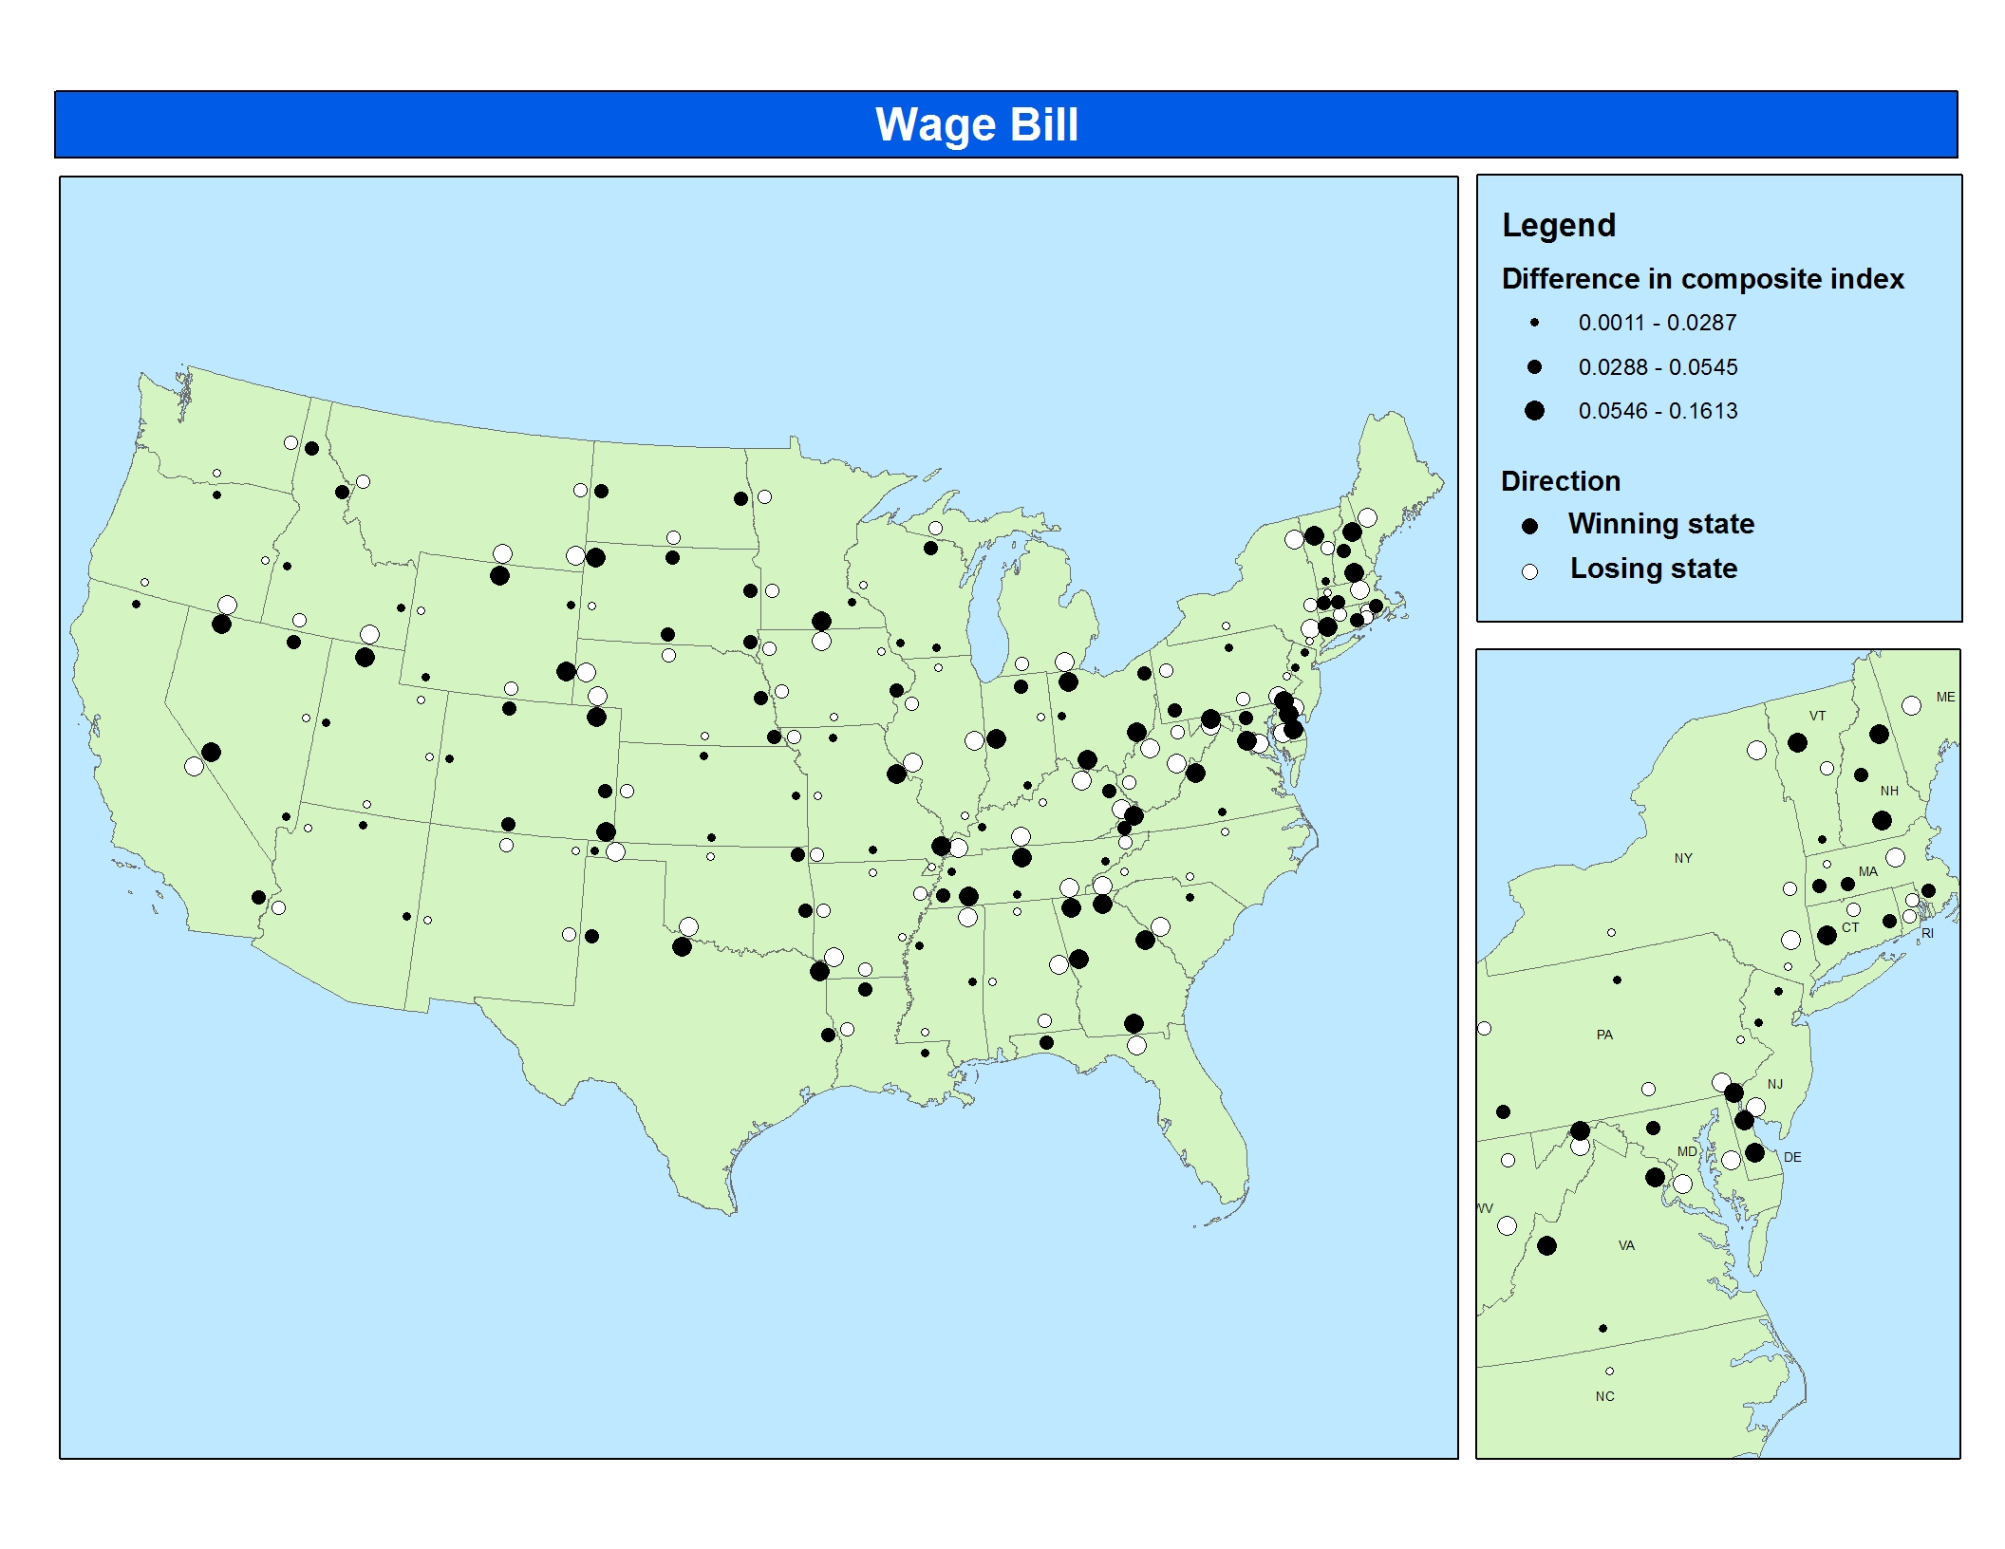
Figure 2: Relative Business Climate for Wage Bill Growth, 1992-2002
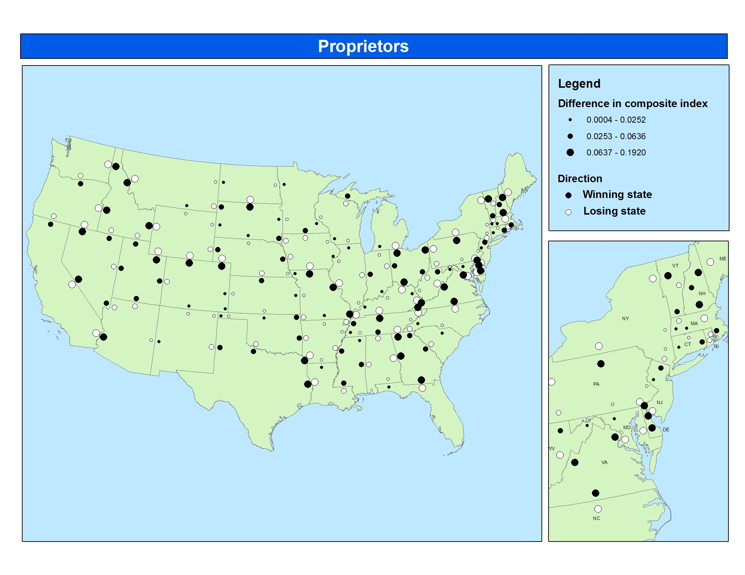
Figure 3: Relative Business Climate for Proprietor Growth, 1992-2002
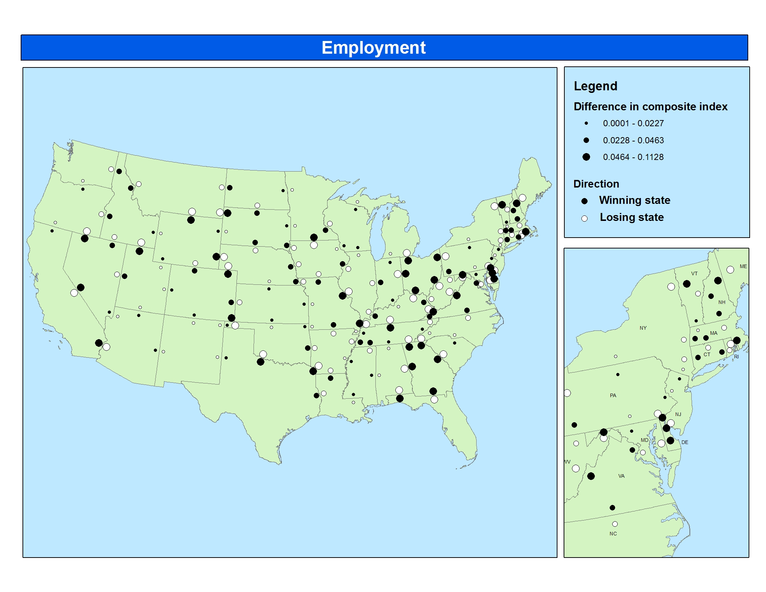
Figure 4: Relative Business Climate for Employment Growth, 1992-2002
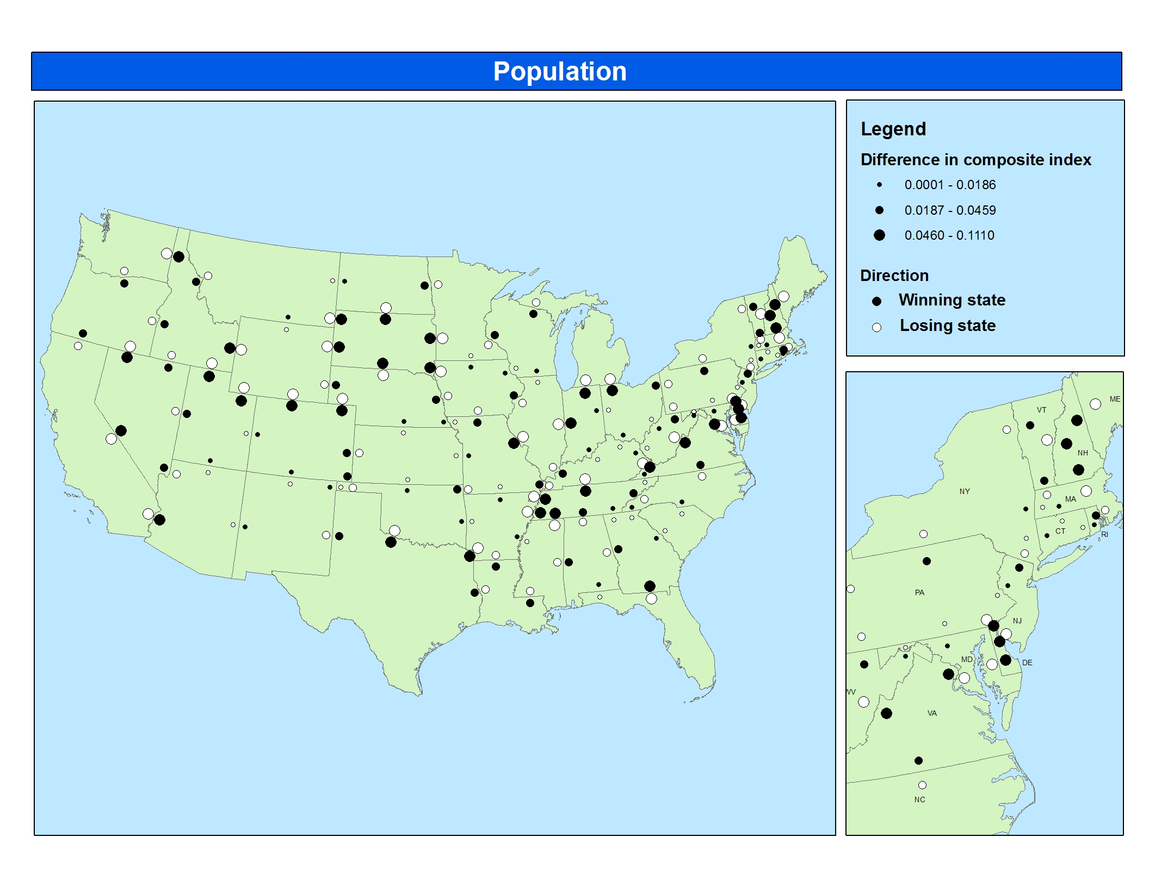
Figure 5: Relative Business Climate for Population Growth, 1992-2002

